Jennifer Chung ([jrc98@njit.edu](mailto:jrc98@njit.edu))

## Project 4 - Final Project - Content and Project (Final Project)

1. GitHub Repository - <https://github.com/JRC98-NJIT-GitHub/Final-Project.git>

2. Screenshots of the following:

I. thru III (Homework 5 forked with Final Project) – Screen shots for Project 3 and Homework 5 available in the repo here. [JRC98 IS601 Project3 073021.docx](https://github.com/JRC98-NJIT-GitHub/Final-Project/blob/master/JRC98%20IS601%20Project3%20073021.docx) and [JRC98 IS601 HW5 072321.docx](https://github.com/JRC98-NJIT-GitHub/Final-Project/blob/master/JRC98%20IS601%20HW5%20072321.docx)

. 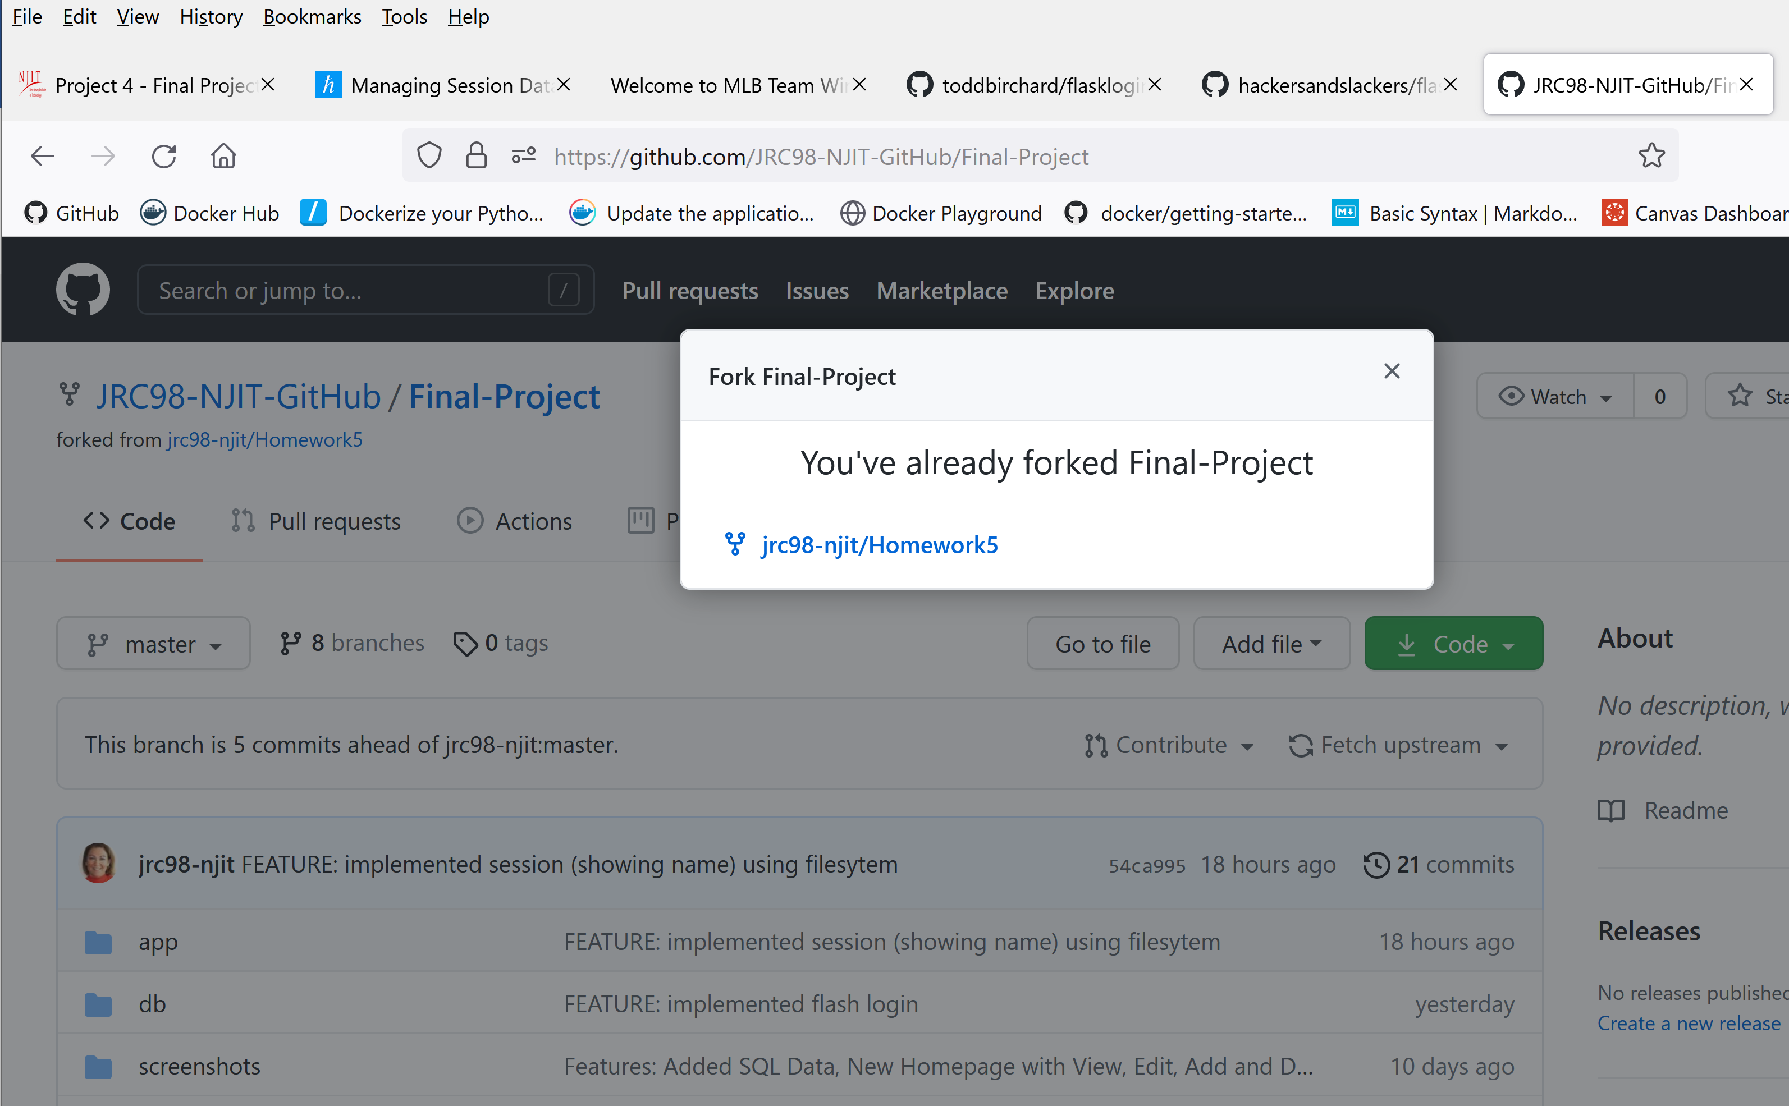

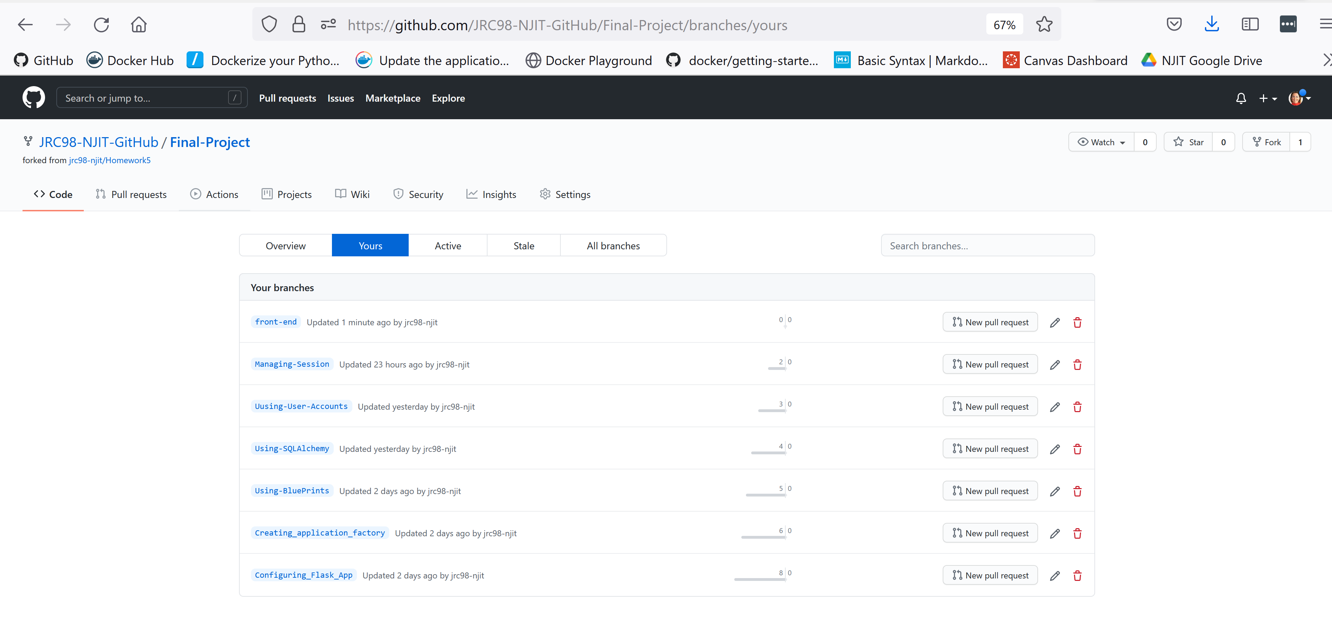

V. Configure Flask Application (no UI changes here, backend work)

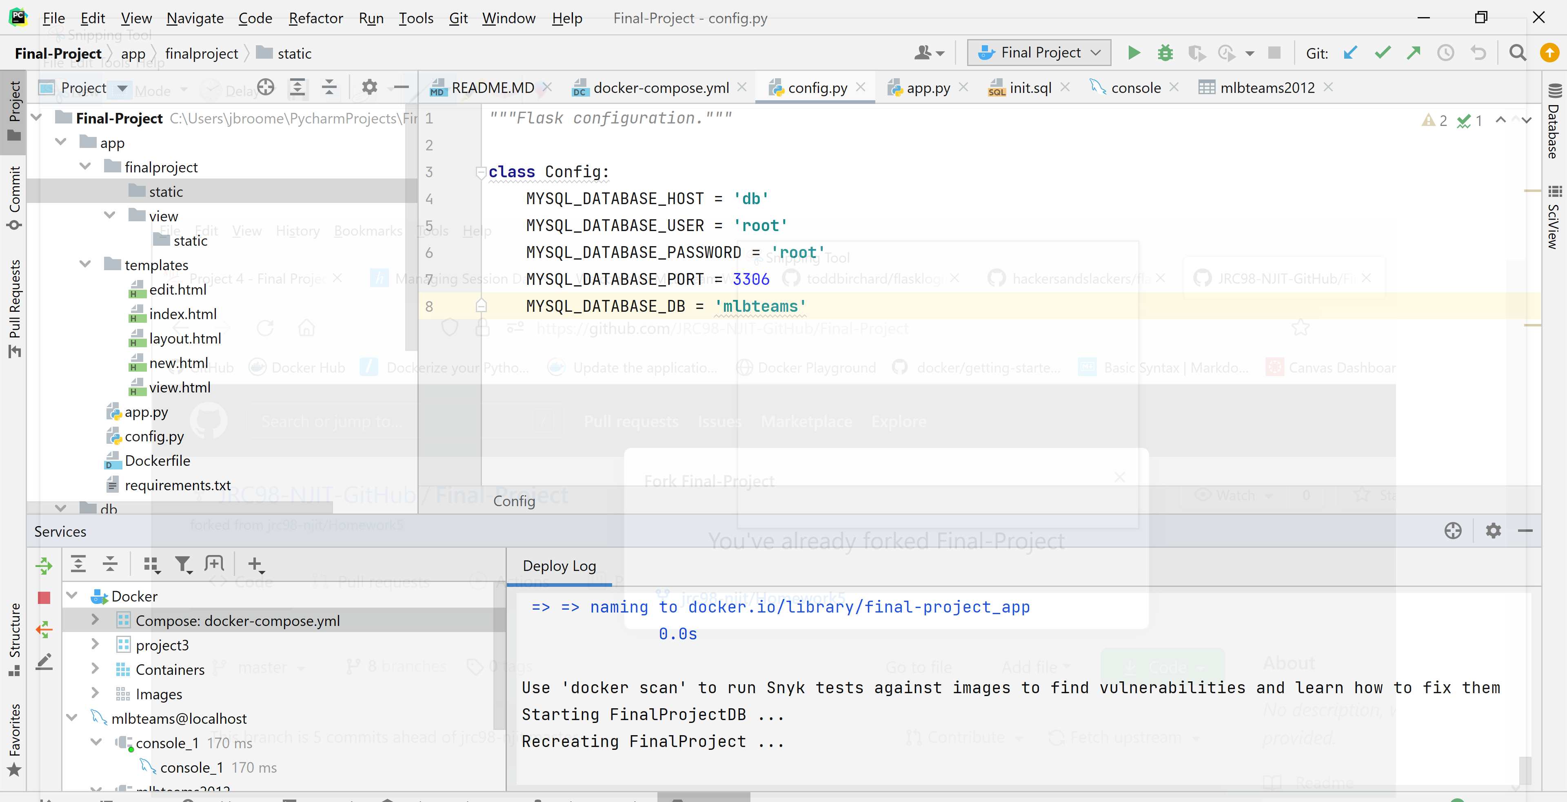

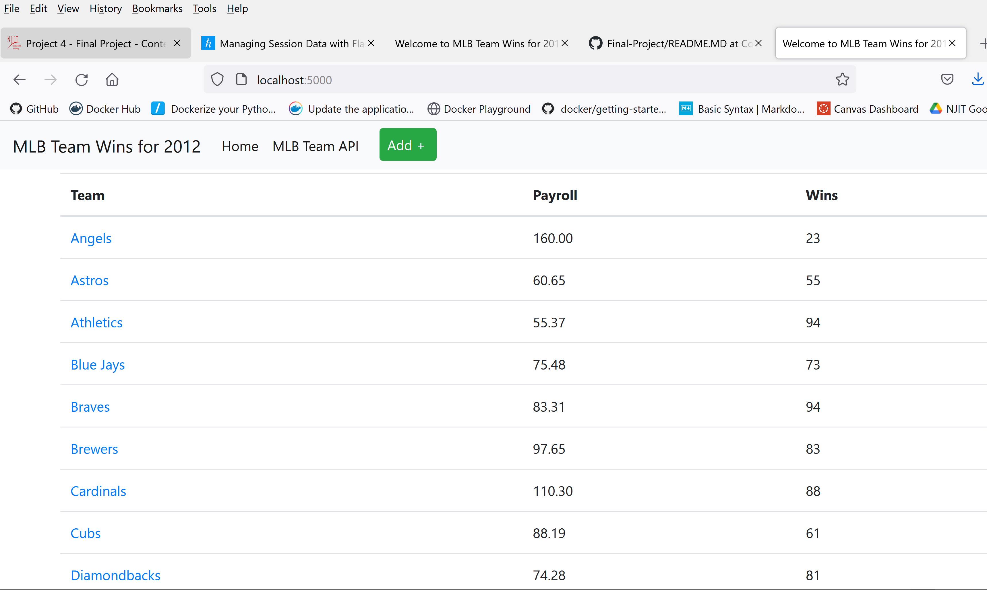

VI. Demystifying Flask’s Application Factory (no UI changes here, backend work)

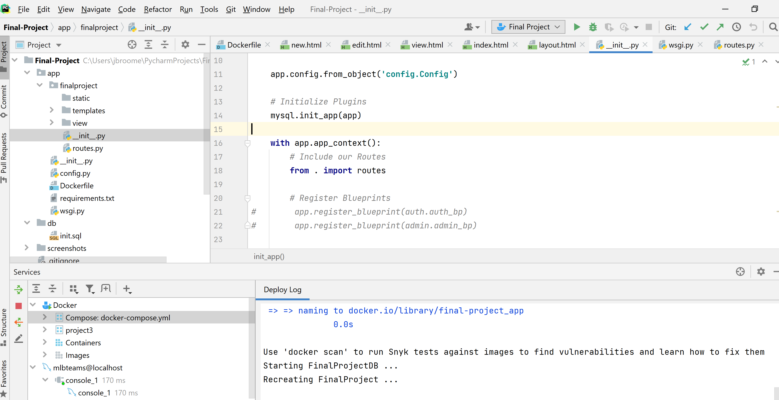

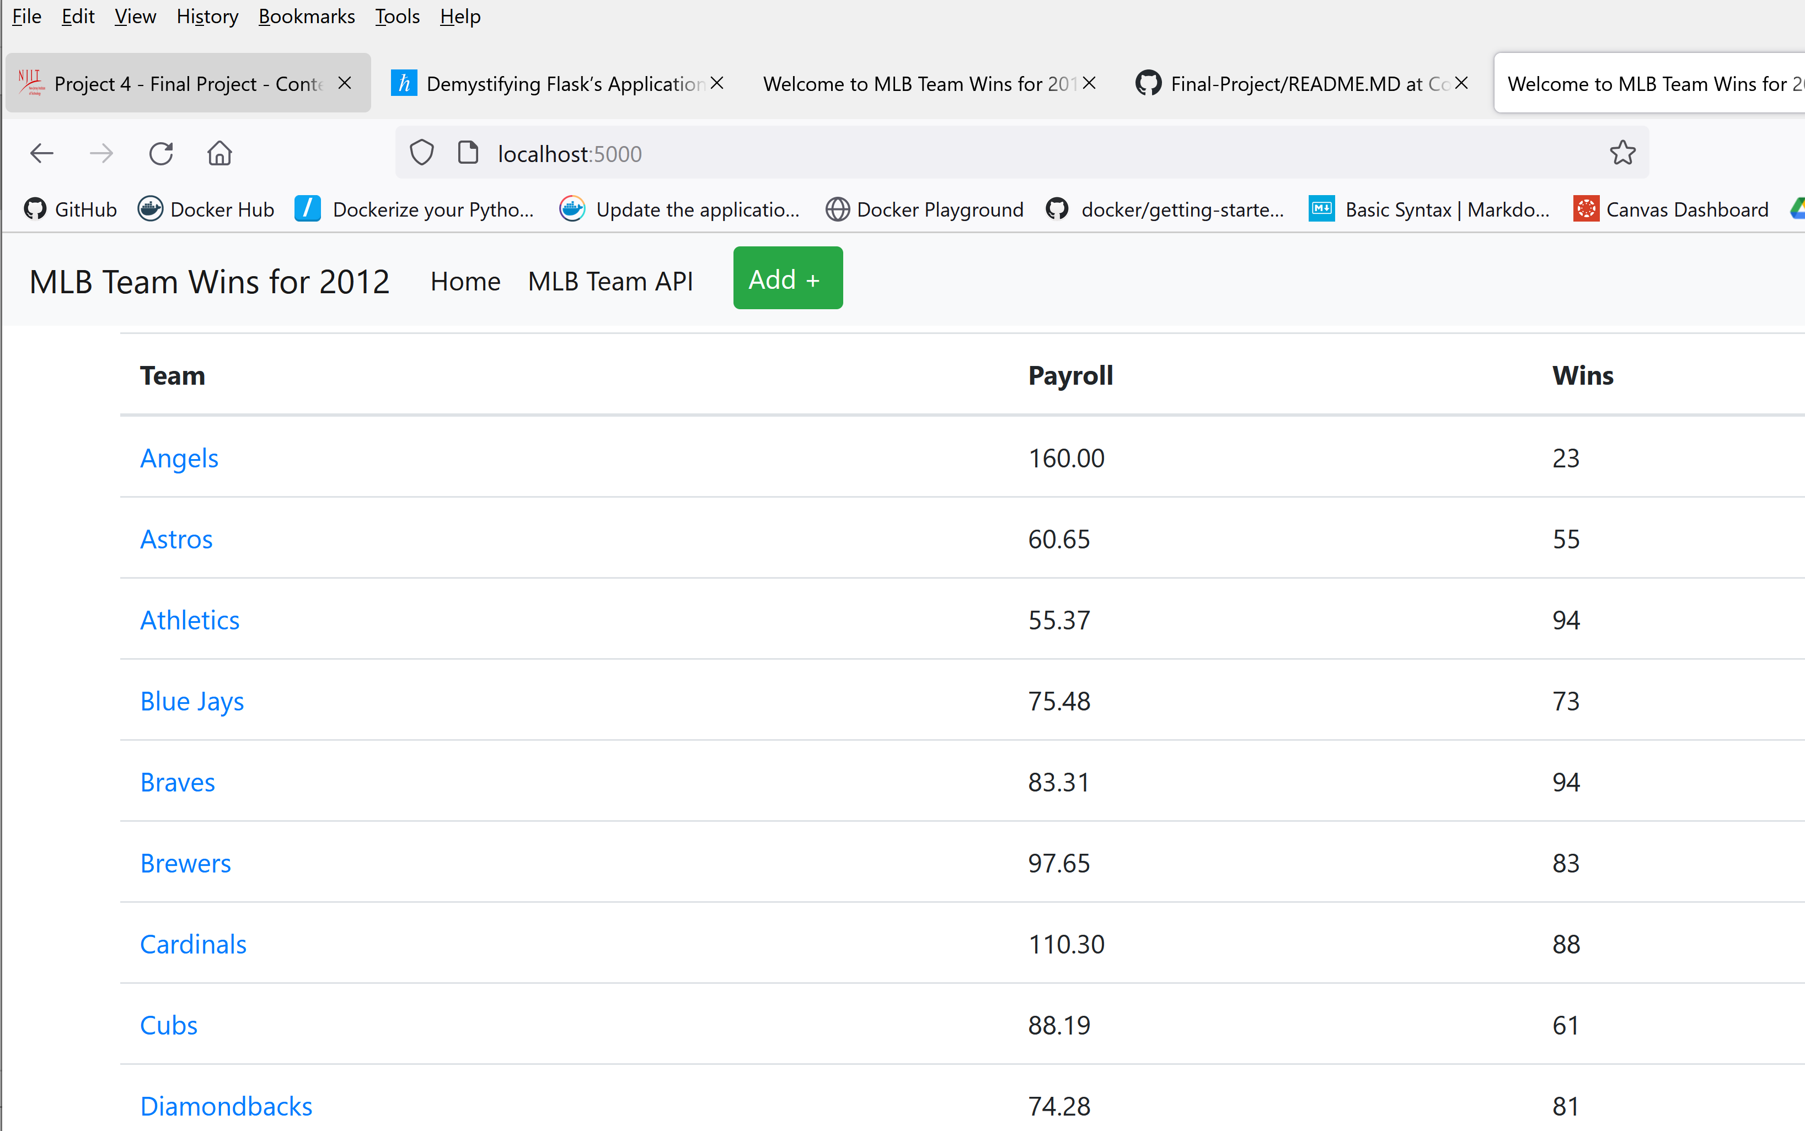

VII. Organizing Flask Apps with Blueprints

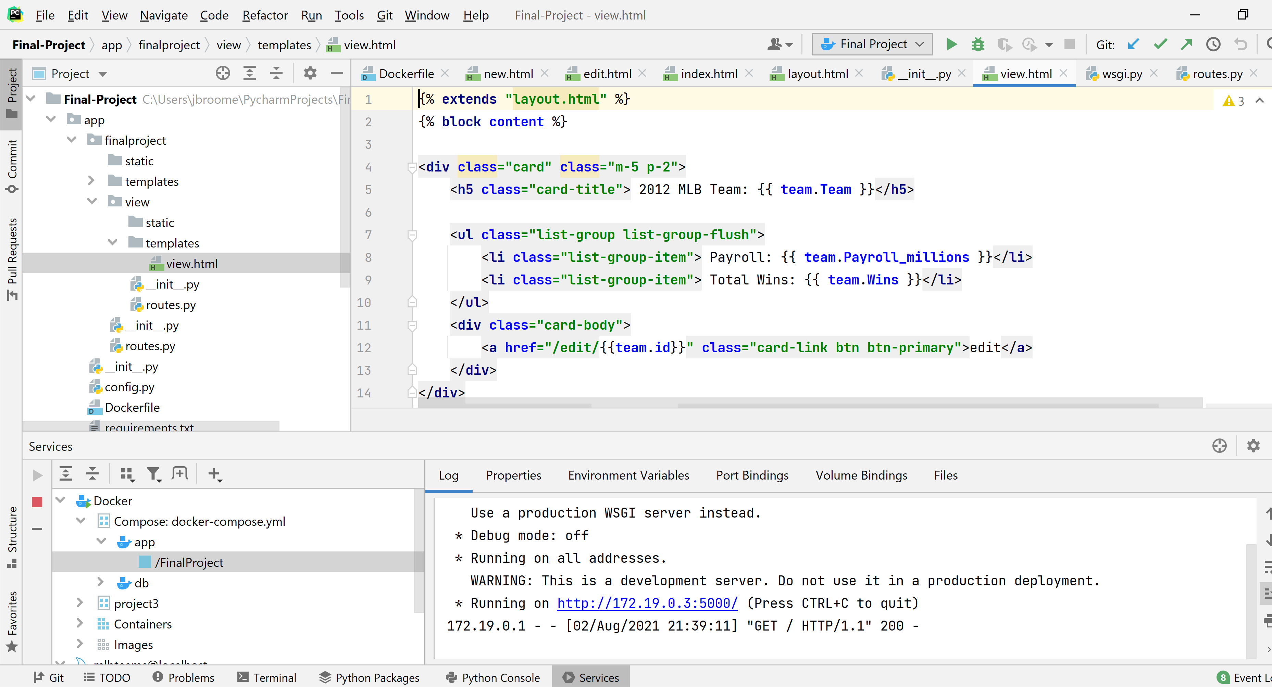

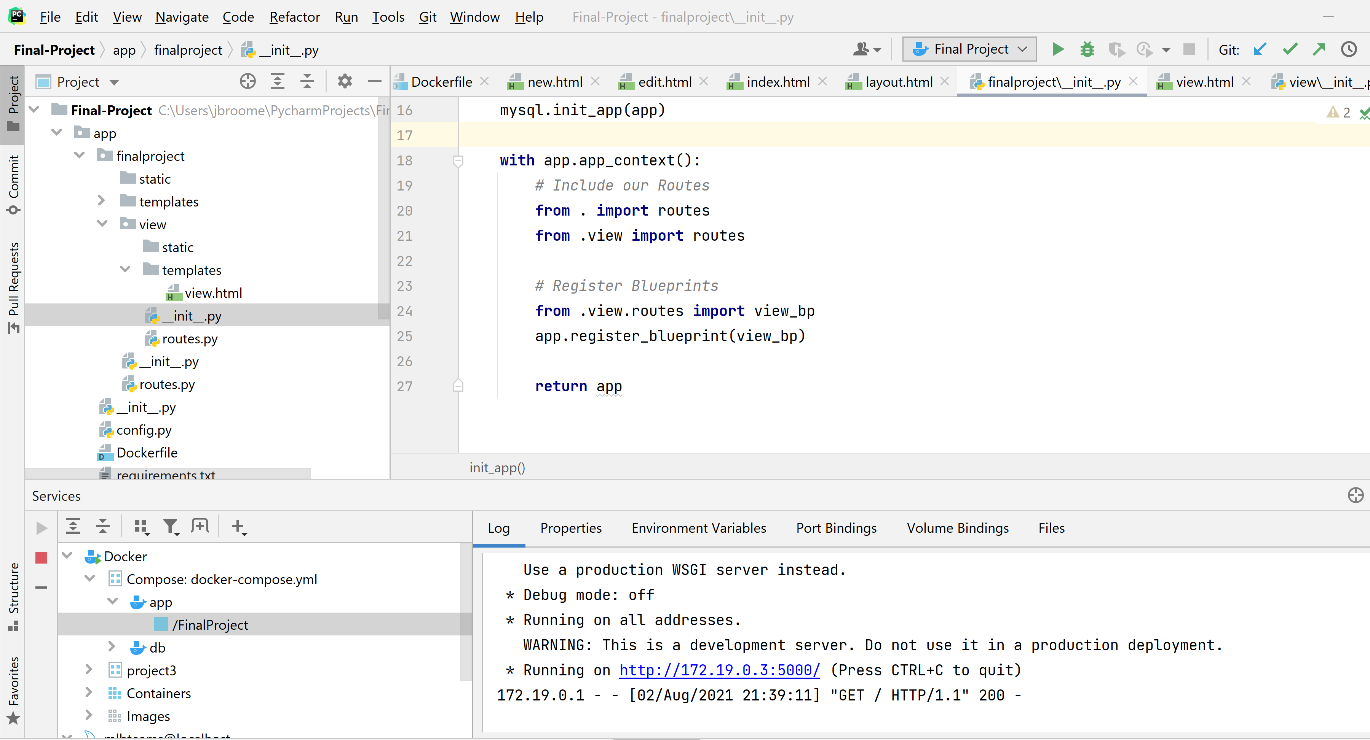

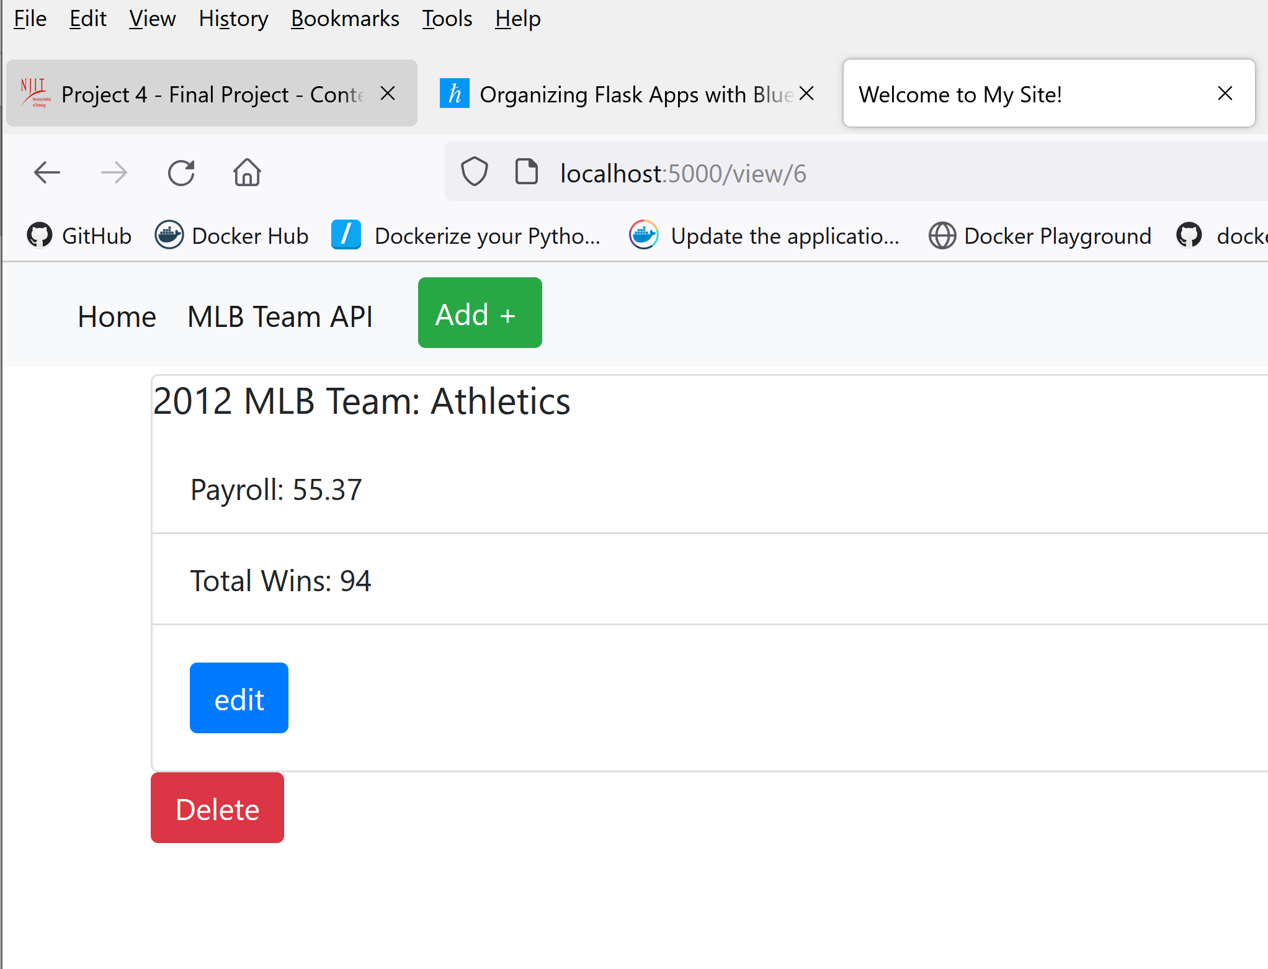

VIII. Compiling Frontend JavaScript & Stylesheets Flask

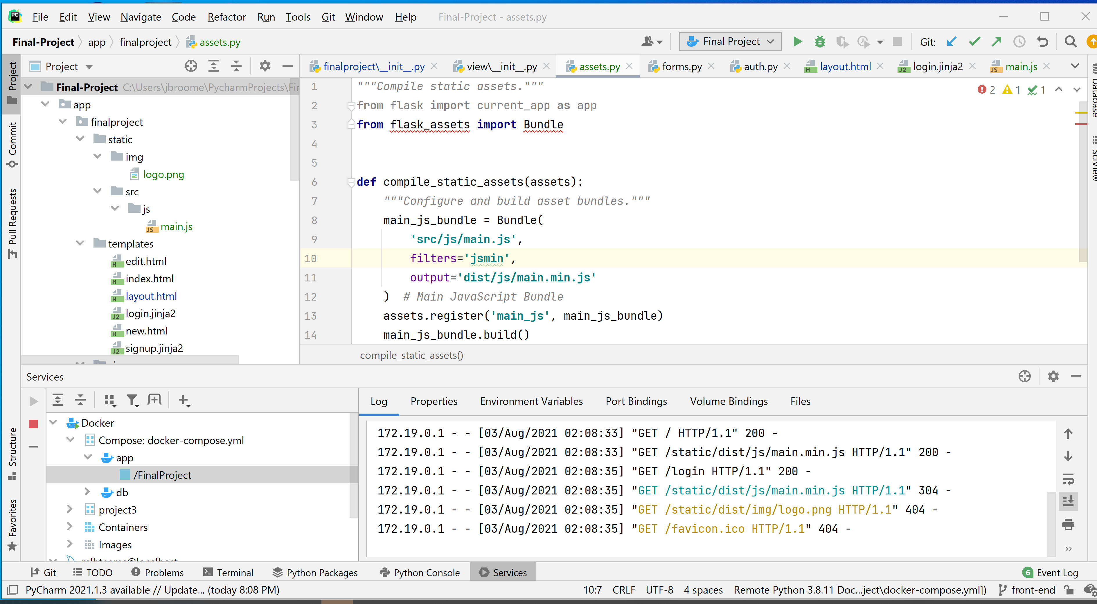

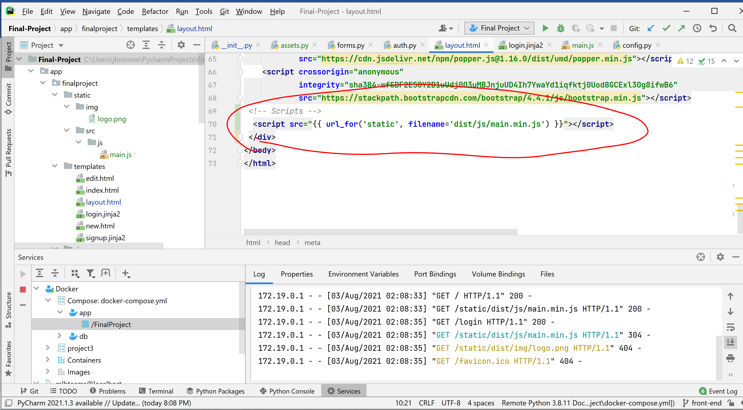

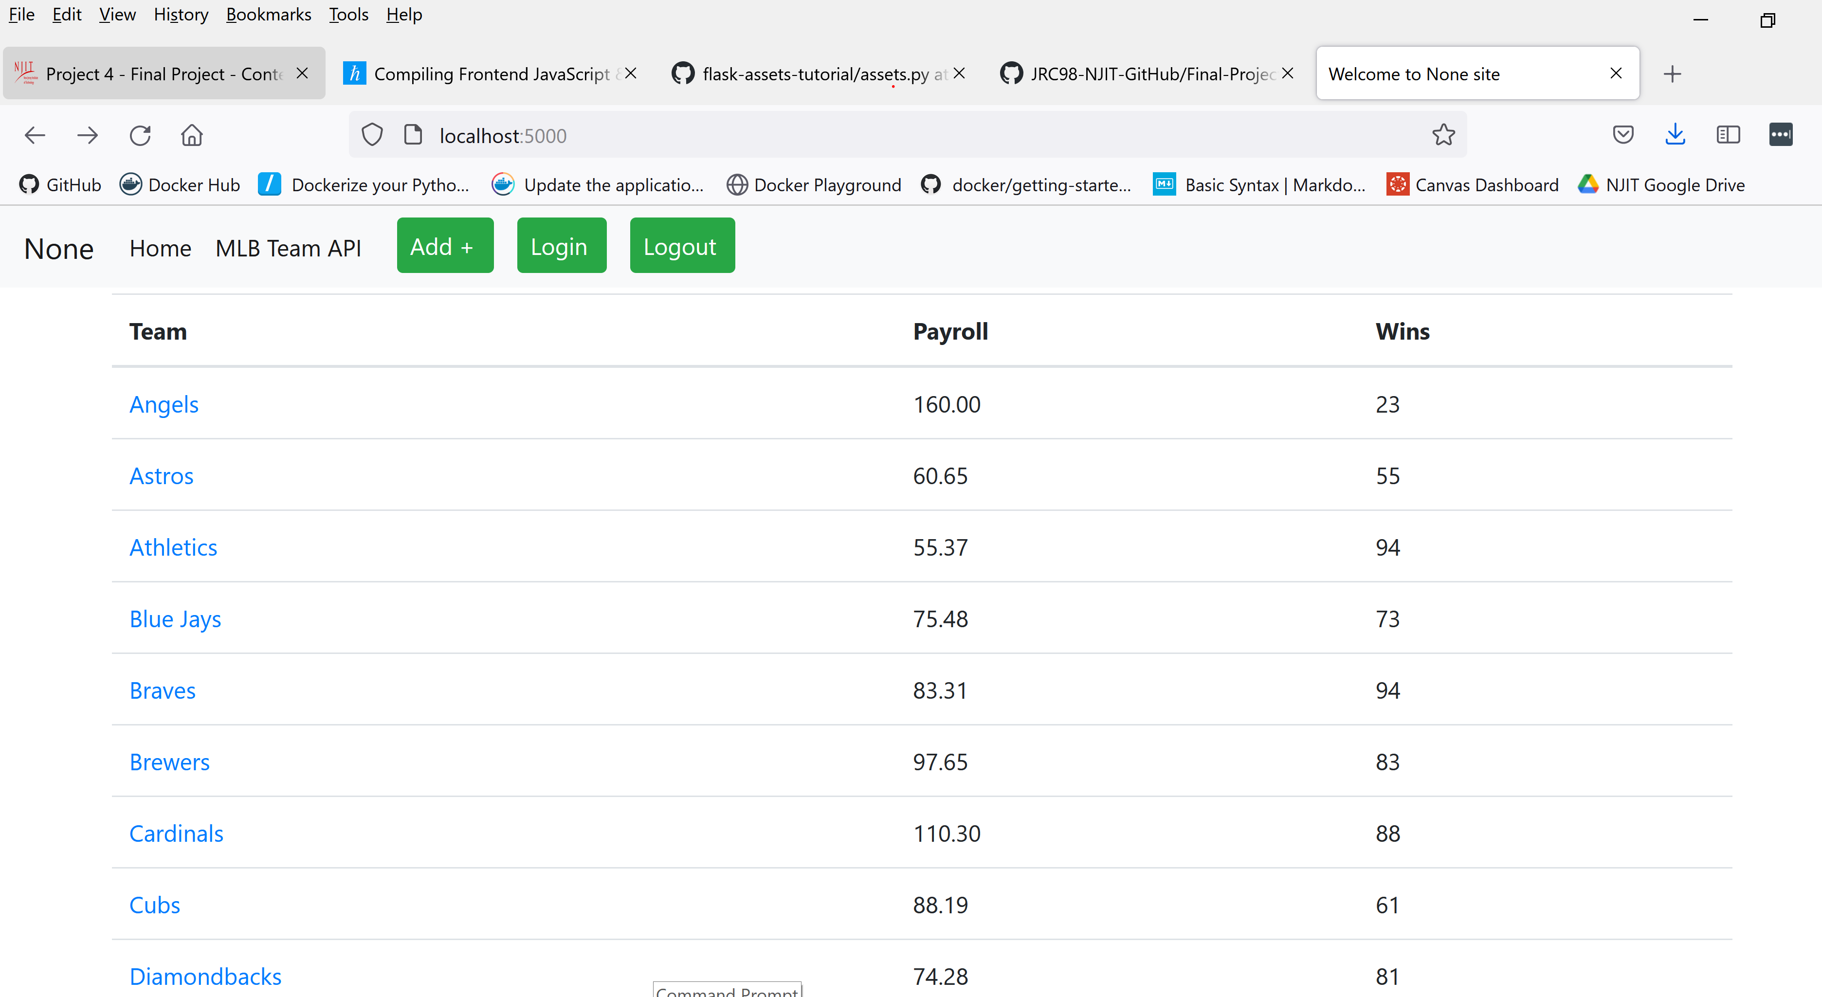

IX. Connect Flask to a Database with Flask-SQLAlchemy

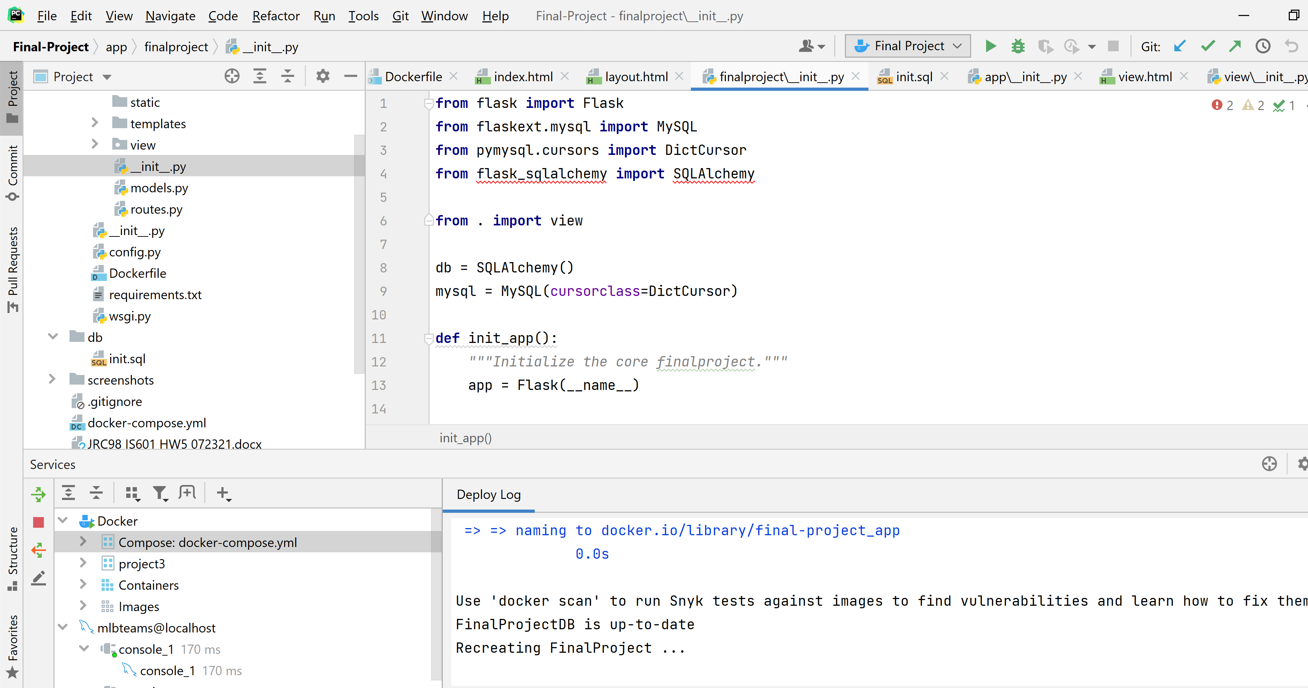

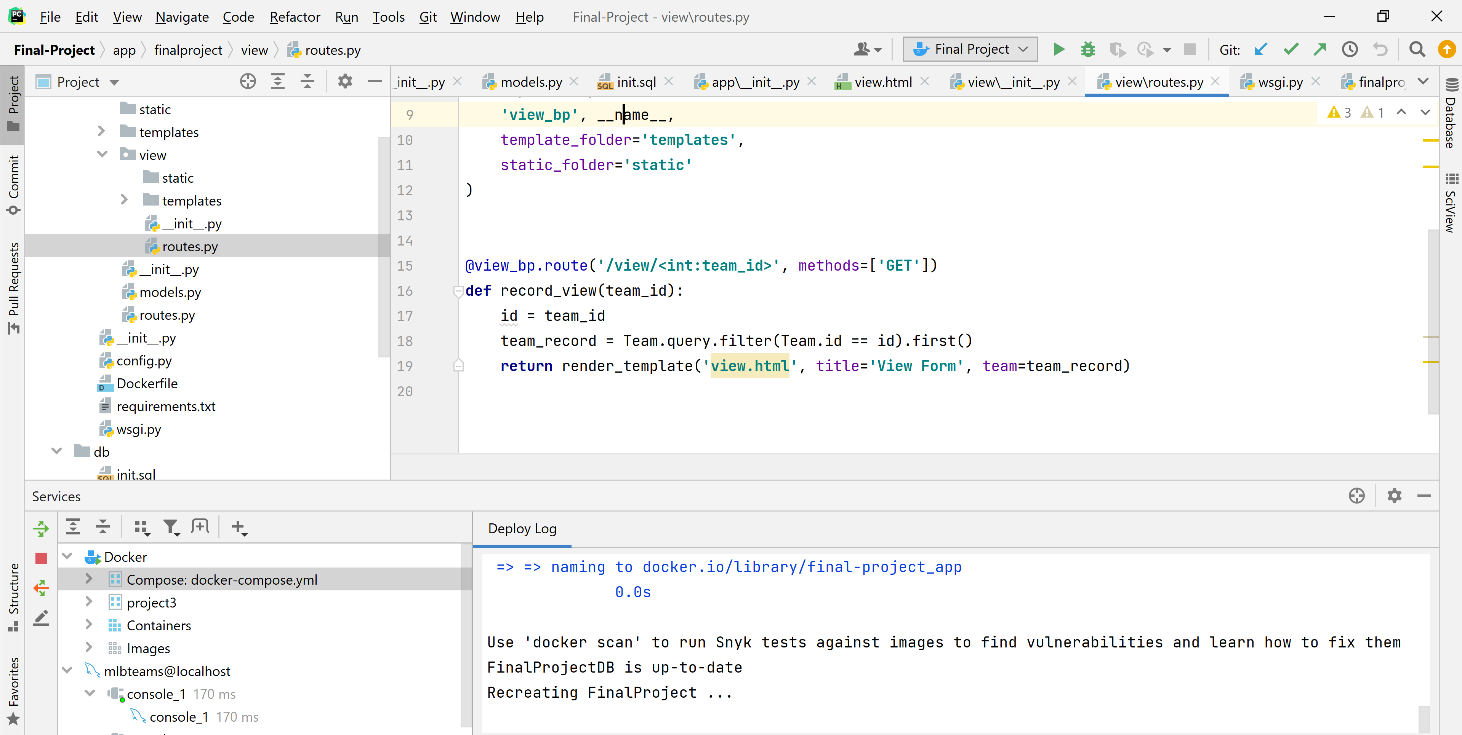

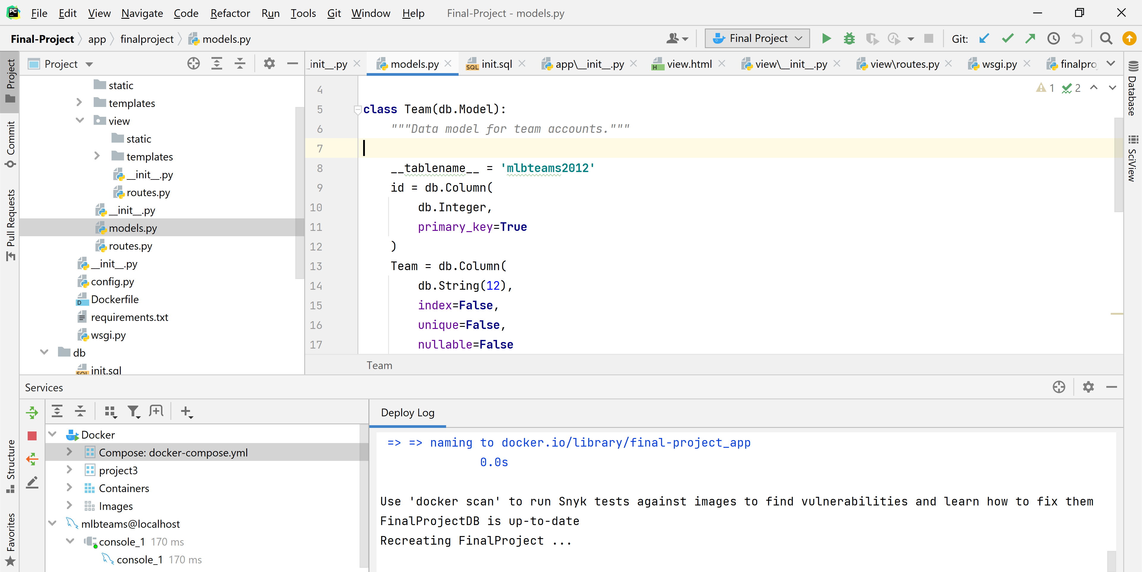

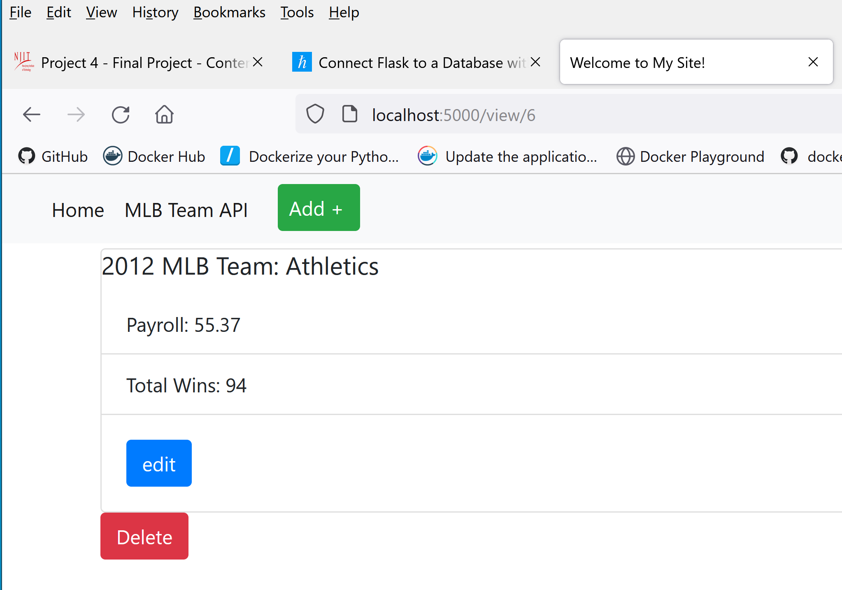

X. Handle User Accounts & Authentication in Flask with Flask-Login

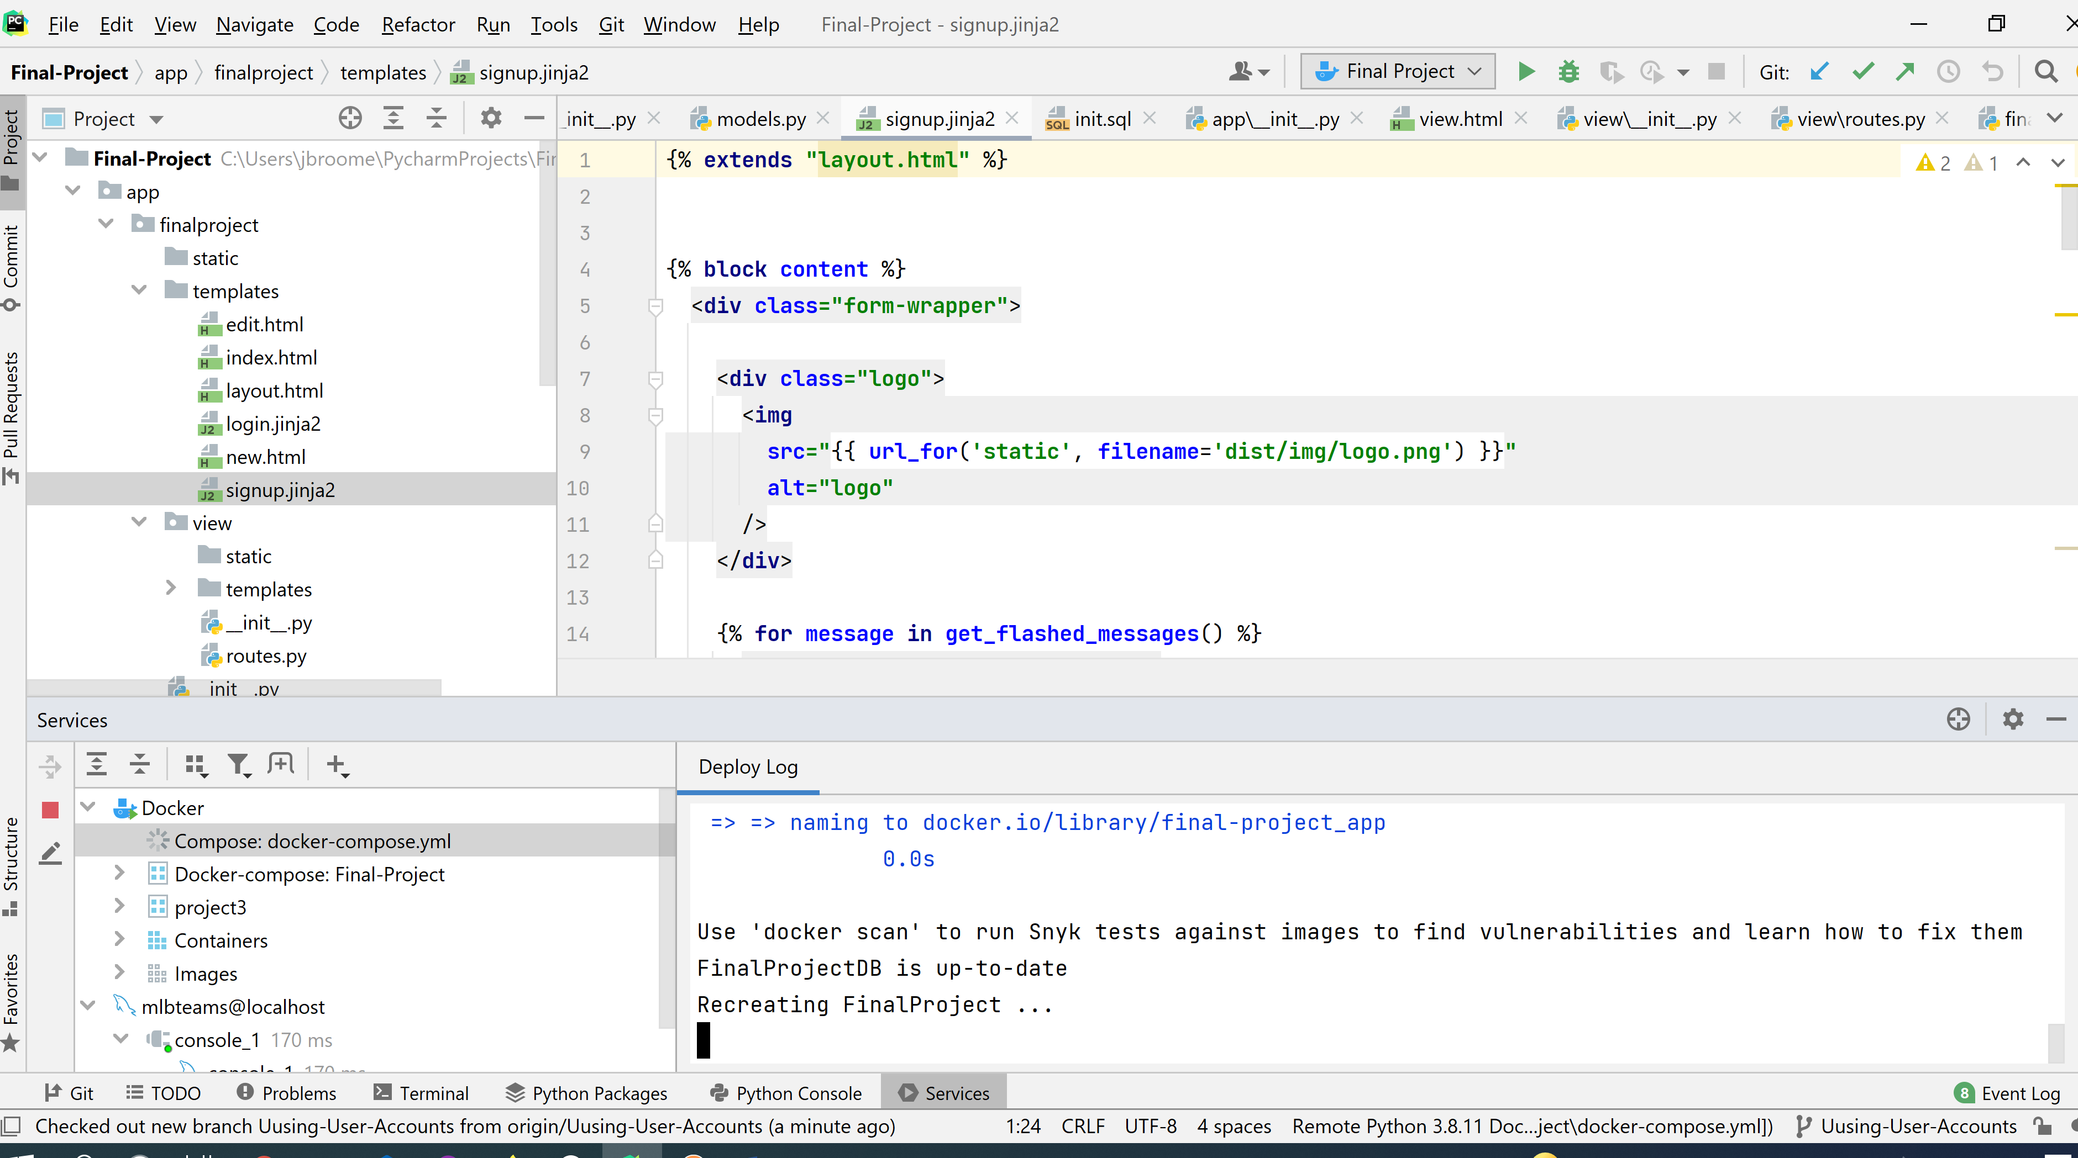

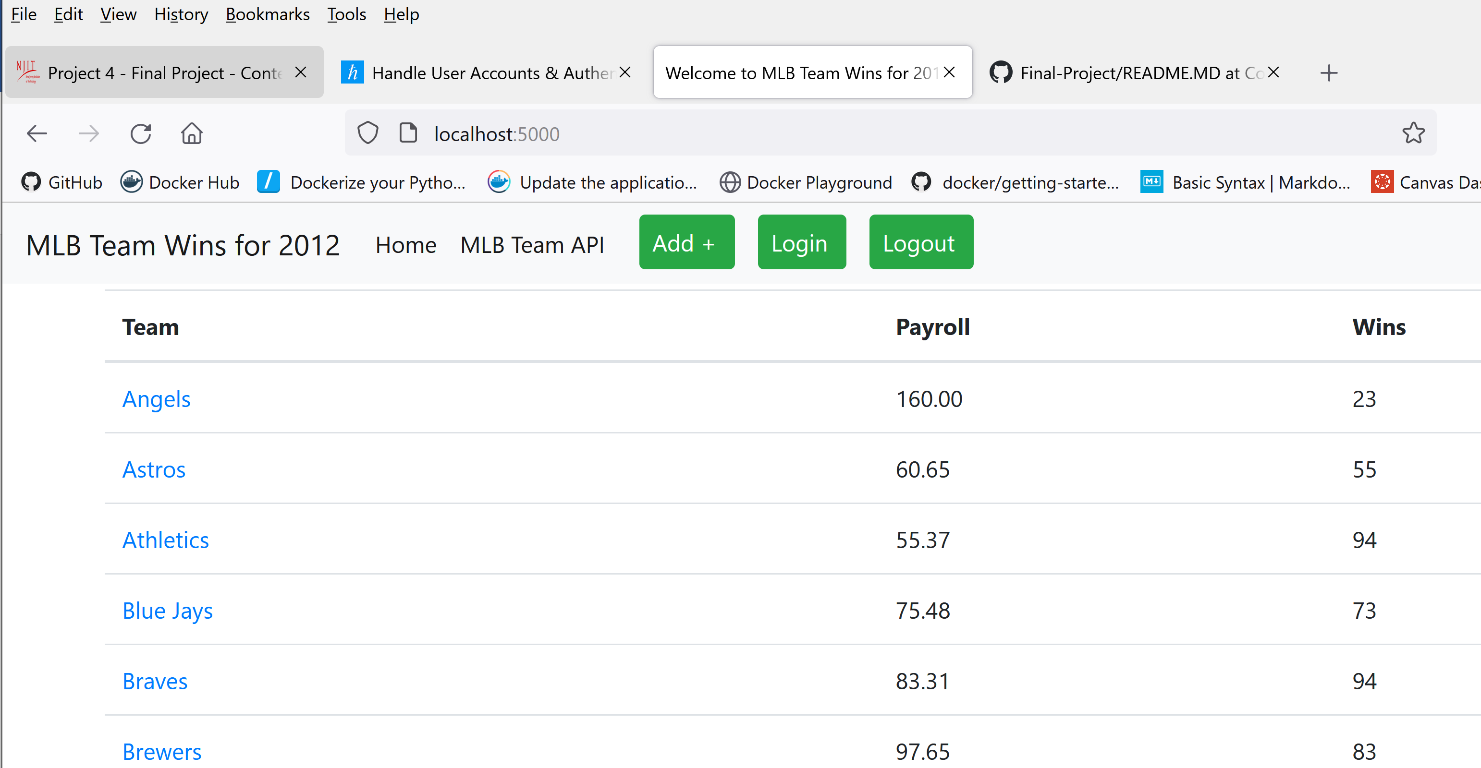

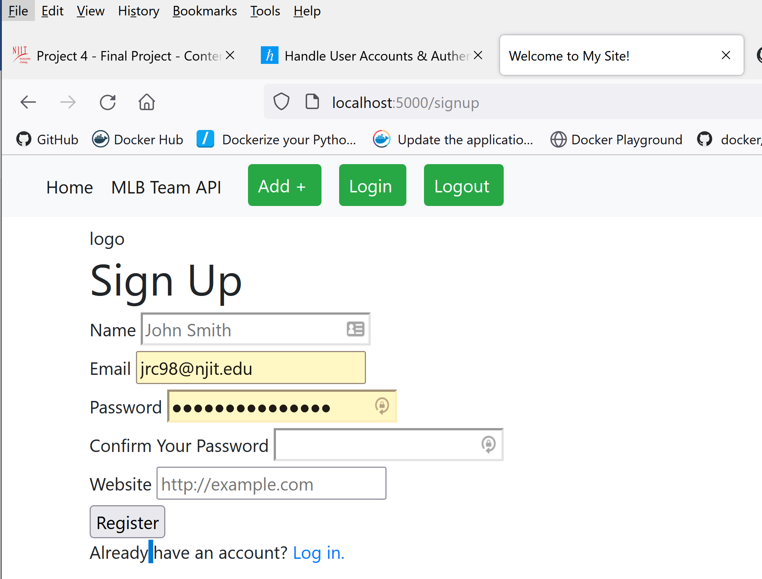

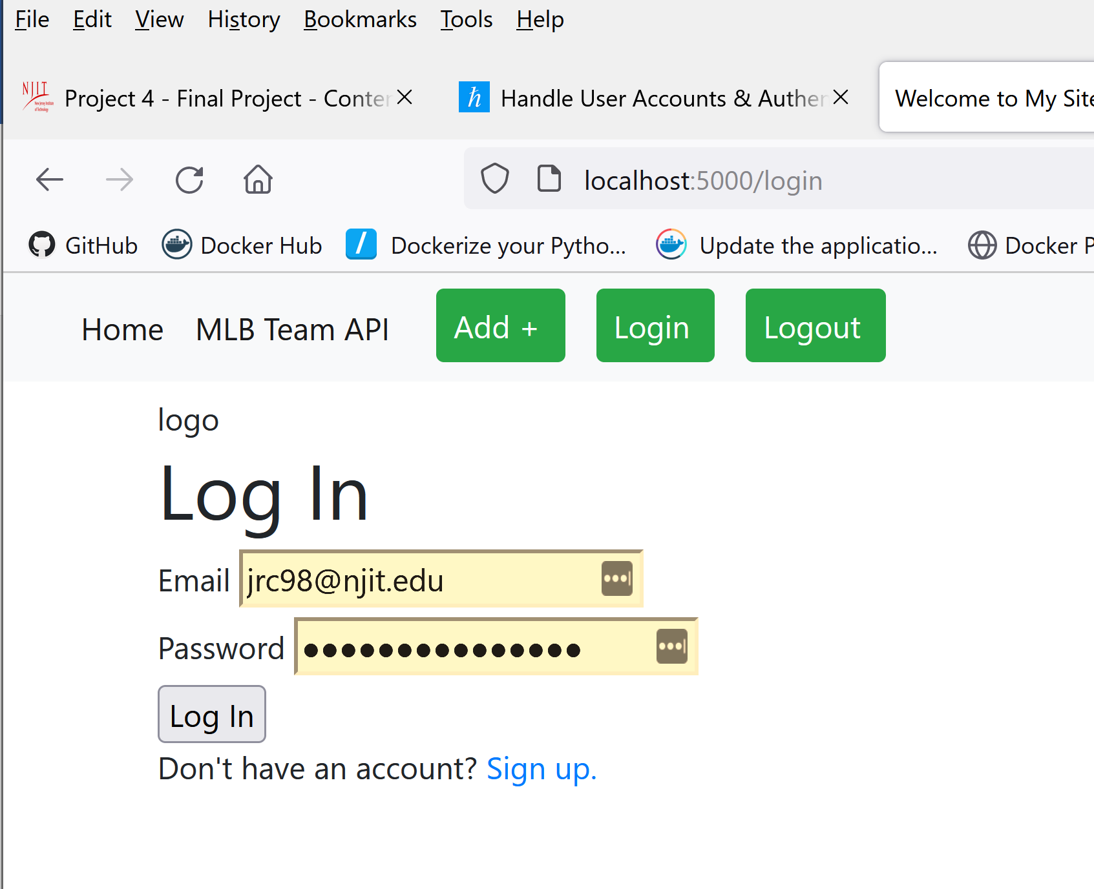

XI. Managing Session Data with Flask-Session & Redis

Before Login…

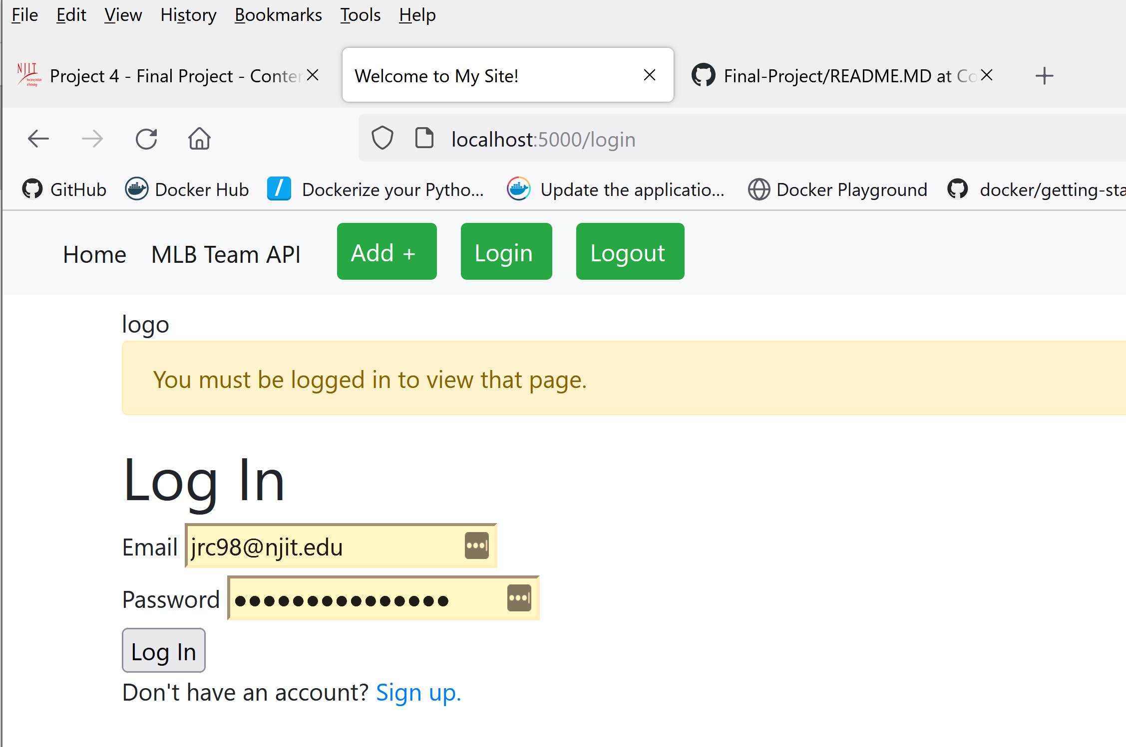

After Log In….

